ZH USB card manual
- Go to our official website to download LED Control System V3.56: www.zhonghangled.com/en. After installing the software, double-click the icon to run the software.

- Firstly you should set the parameters correctly. You could choose config----screen setting--(input the password:168) to set the parameters of your screen and the modules. 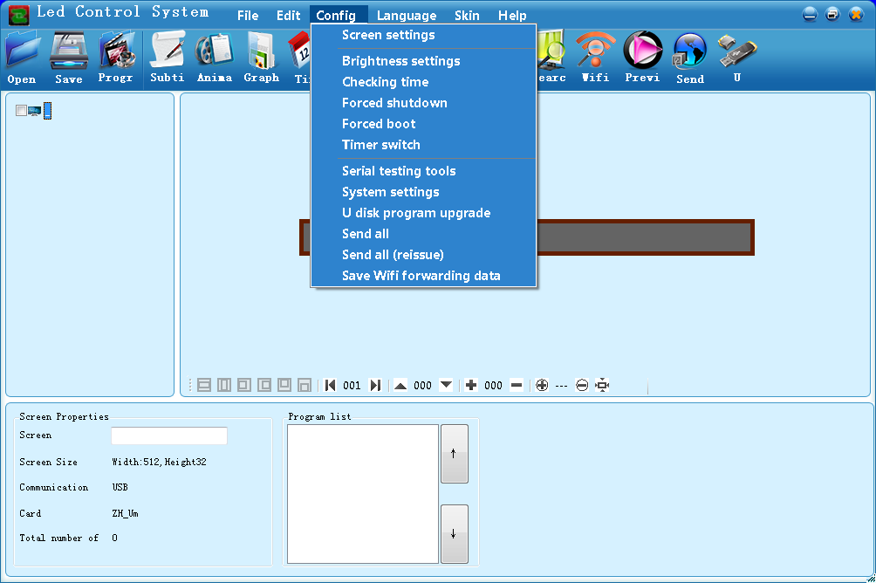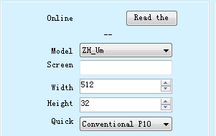
Communication mode choose U disk，other options keep the default selection, and then click save and close.

- Editing program, click “subti” directly.
Input and edit the content to be displayed in the subtitle’s attribute box.
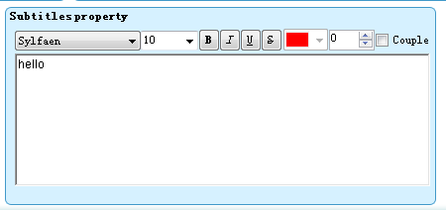
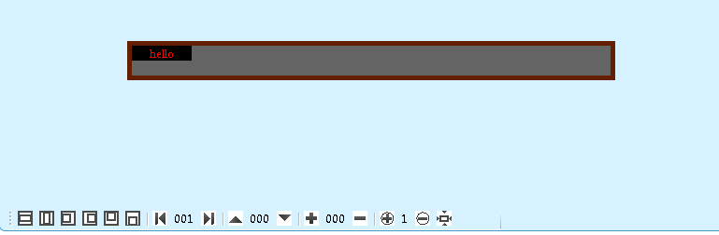
Draw the side of the black area side to expand
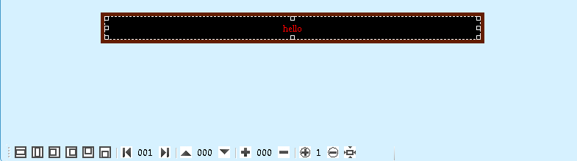
Select the desired effect in the Stunt Show, such as the common continuous left shift.
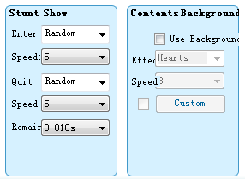

- Sending contents
Click the U button on the software - - choose U disk and click the save button -- prompting data saved successfully
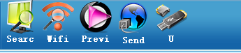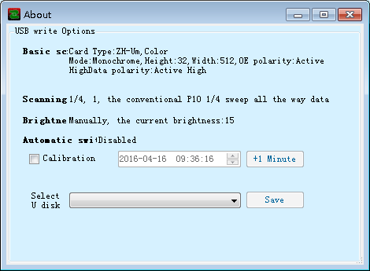

Safety exit U disk, insert U disk to the control card’s USB port or screen’s USB extension line, waiting for the U disk to be read, after that, pull out the U disc, the display will appear what you want.

Common Questions:
- Why does my display show some Chinese?
Answer: Because you chose the wrong card model in the screen setting of software. When it happens, the display will tell you the right card model between the Chinese words. You can reset the screen setting with the new right model.
- How to display multiple lines?
Answer: Click graphic button on the software, click multiple lines in the text list.
- Could I use of the card reader instead of U disc?
Answer: Does not recommend the use of the card reader instead of U disc.
- What to do when display does not read U disk?
Answer: Formatting the U disk (When formatting, file system select FAT32, and cancel fast format). If it still couldn’t work, please change another U disk.
- What to do when running software does not display the whole content?
①XP system: Point on the screen with the right mouse button - properties - settings - advanced - general, in the show column, set DPI to normal size 96dip
②Win7 system: control panel--display--make reading the contents of the screen more easily, adjust it to smaller 100%
③Win8 system: Control panel --display --change all projects, adjust the size to smaller 100%

